**📝"MongoDB- The leading NoSQL" Workshop.📈**

* **By Mr. Vimal Daga,**



**🔥My Project:**

**“CURD” operations on MongoDB using Python Flask**

**C: Create Account**

**U: Update Password**

**R: Login**

**D: Delete Account**

**🔹I created a simple login page in which you can perform above mentioned operations.**

**⭕Technologies used:**

* **Python Flask**
* **MongoDB**
* **Html**
* **CSS**

**🔥Some Glimpse:**

**C:(Create Account)**

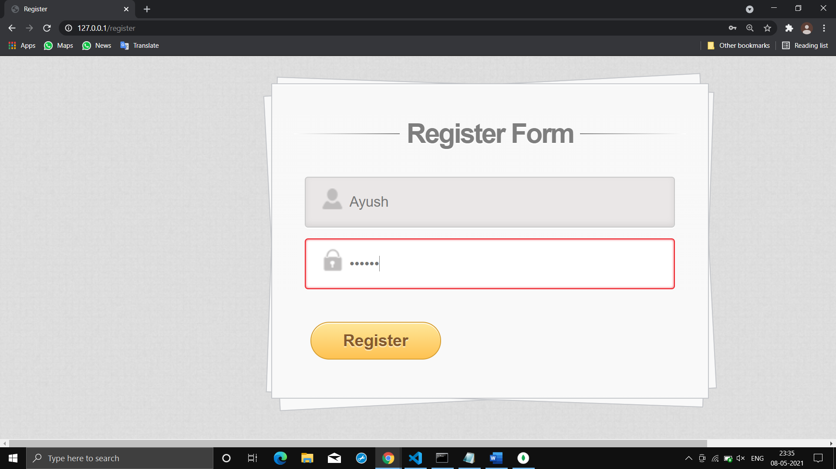

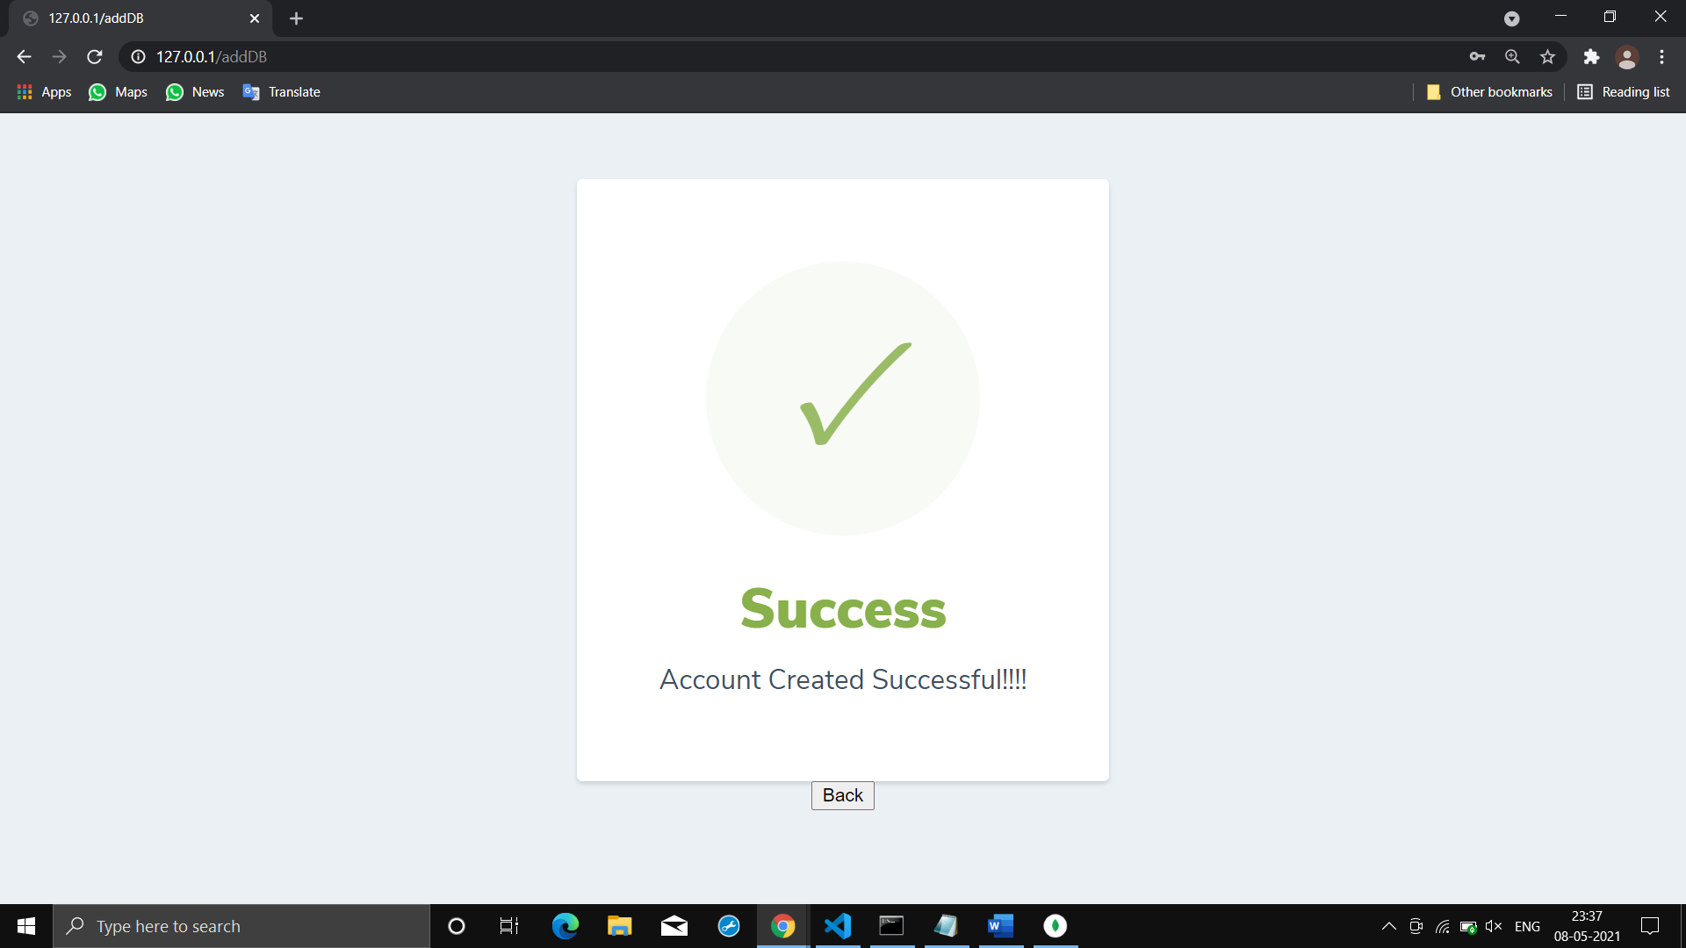

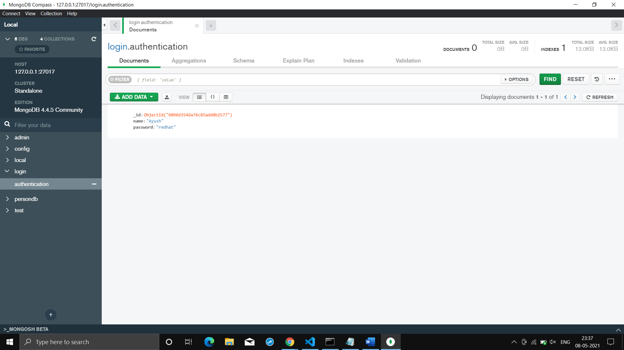

**R:(Login)**

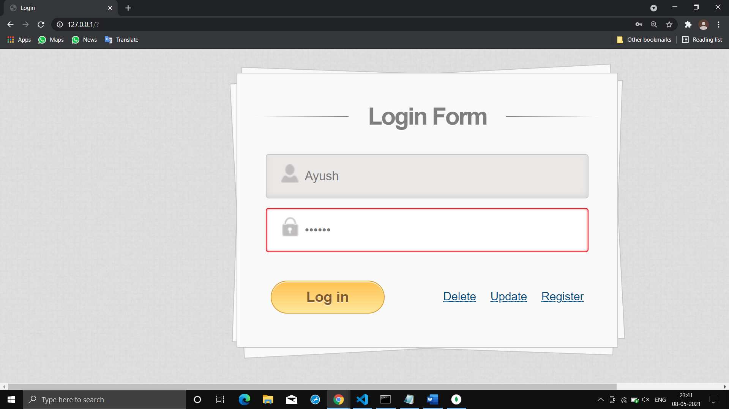

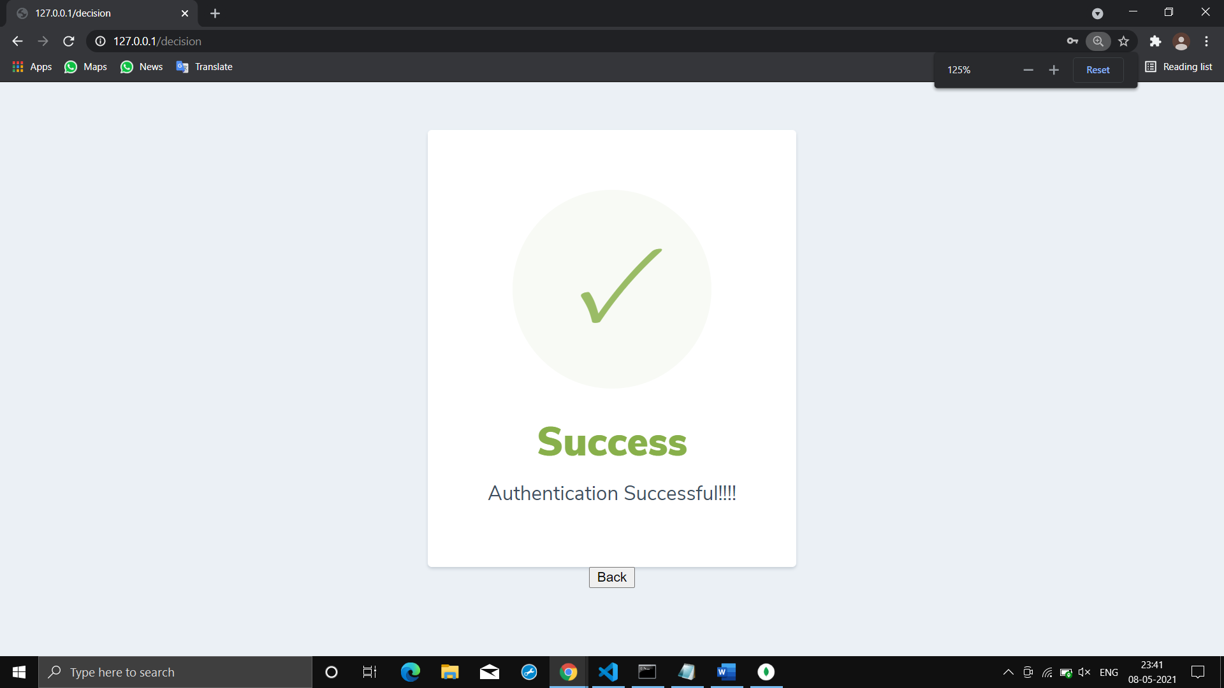

**👉Here, if you give wrong password or username it will give error!!!**

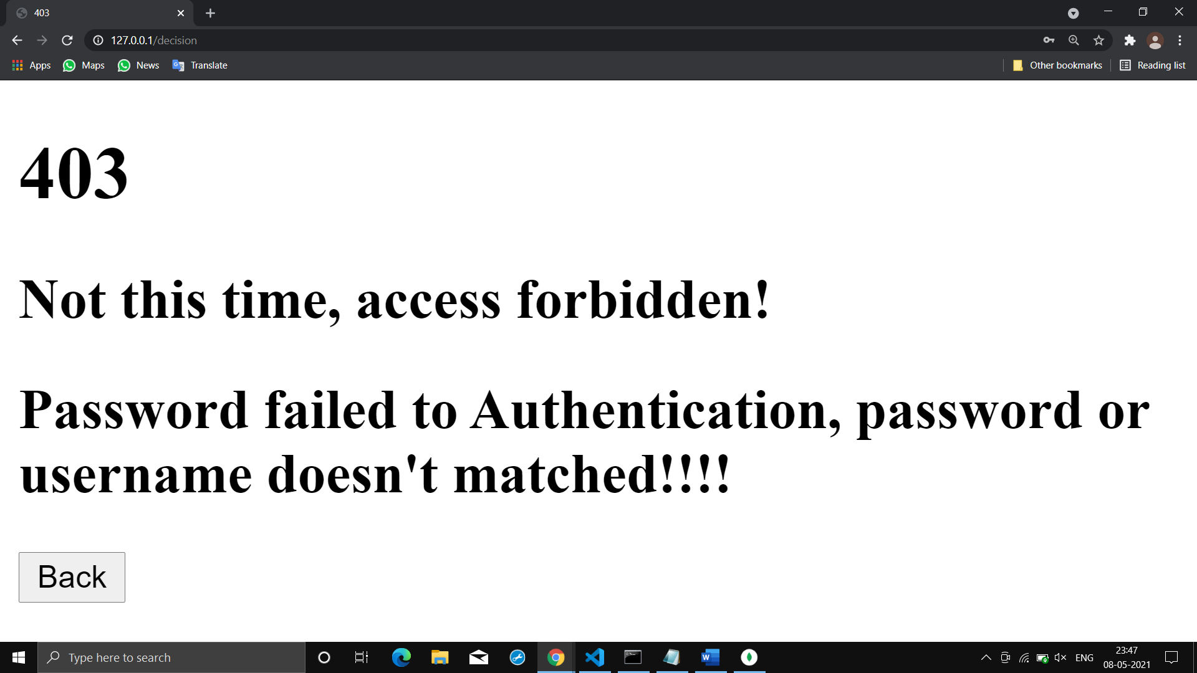

**U:(Update Password)**

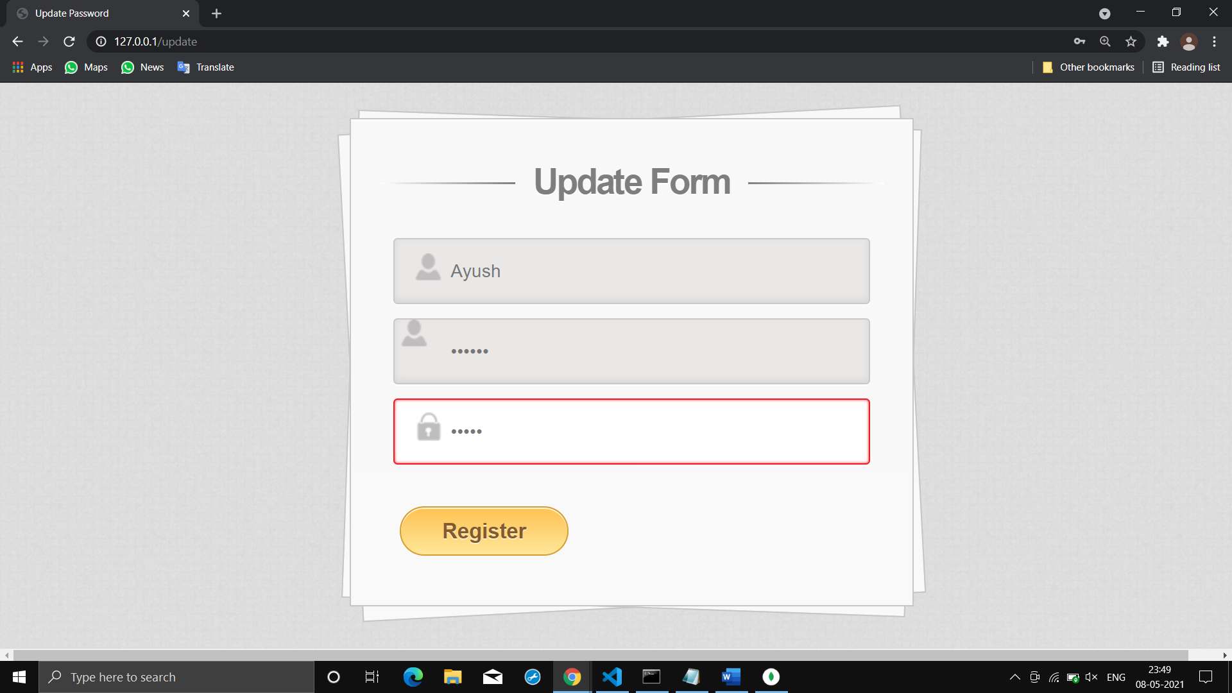

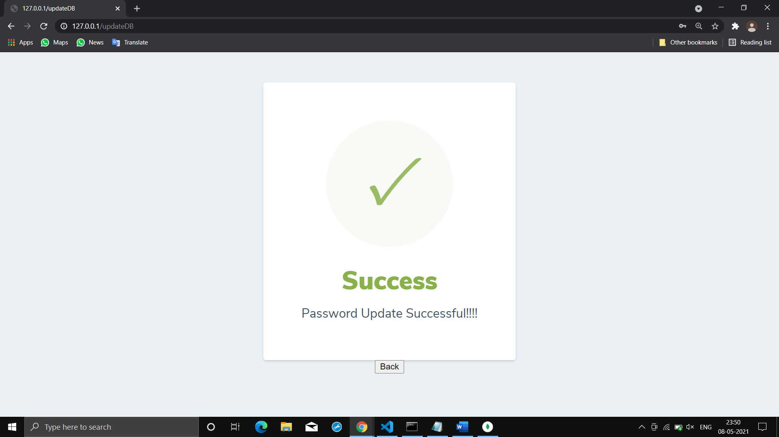

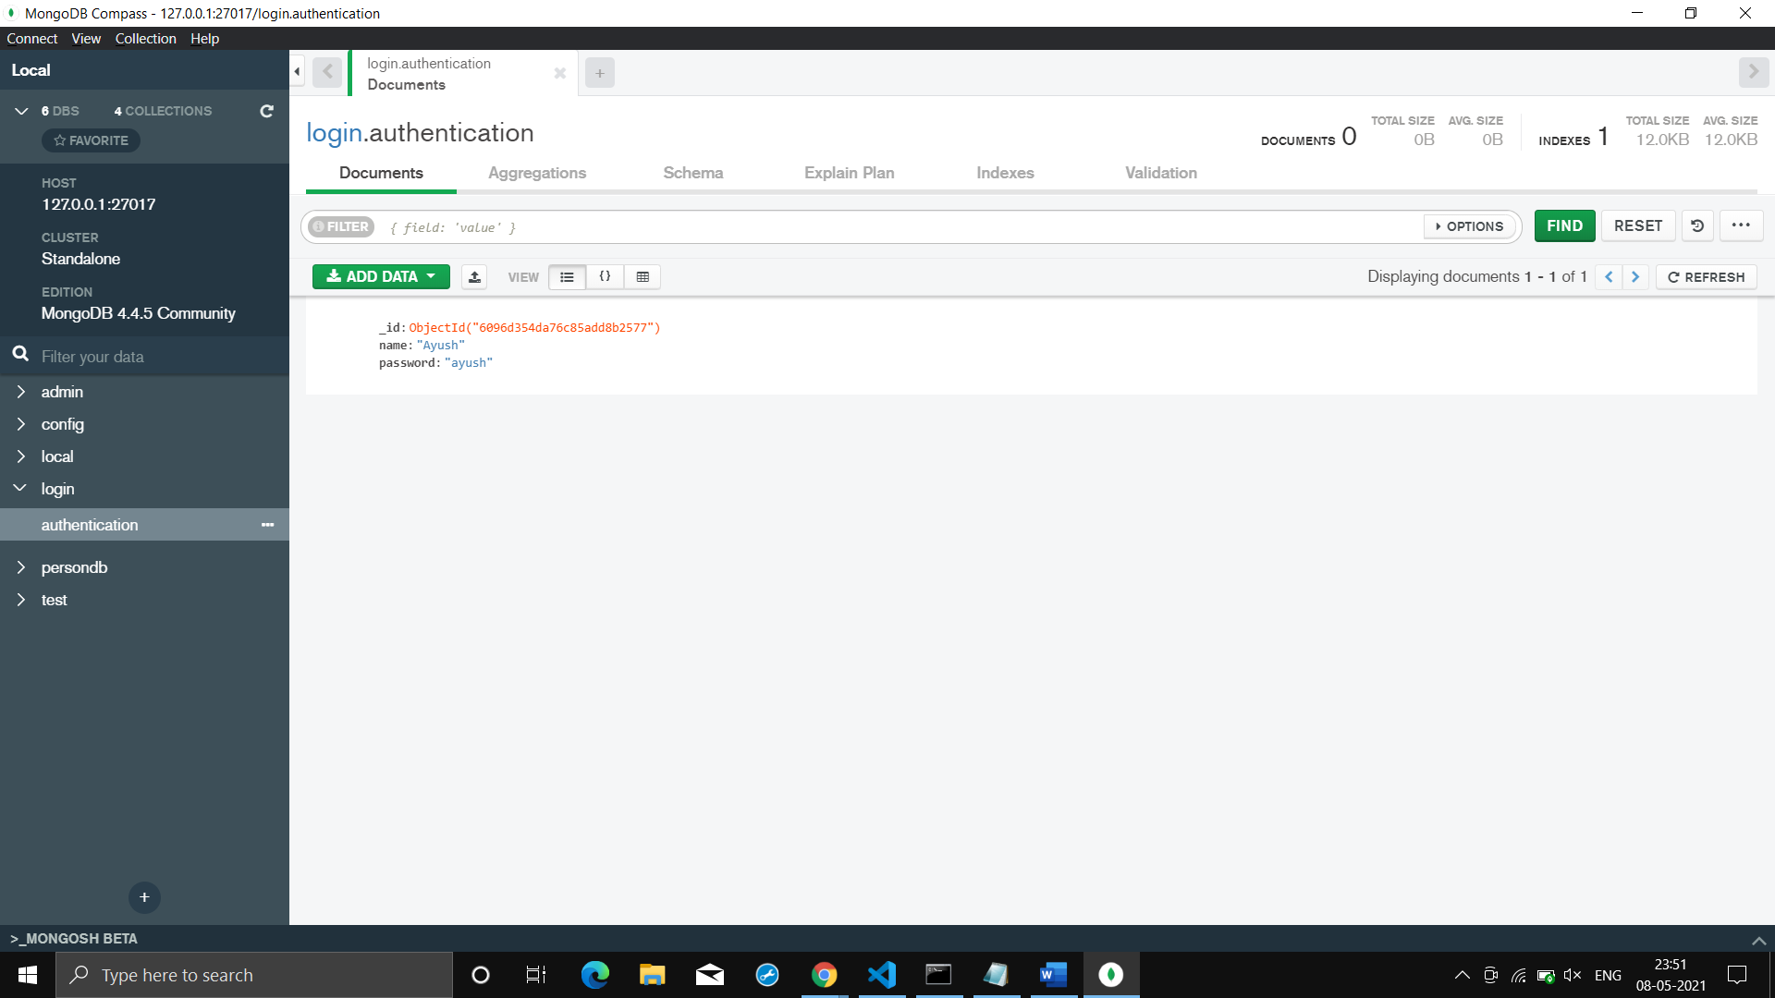

**👉Here, if you give wrong password or username it will give error!!!**

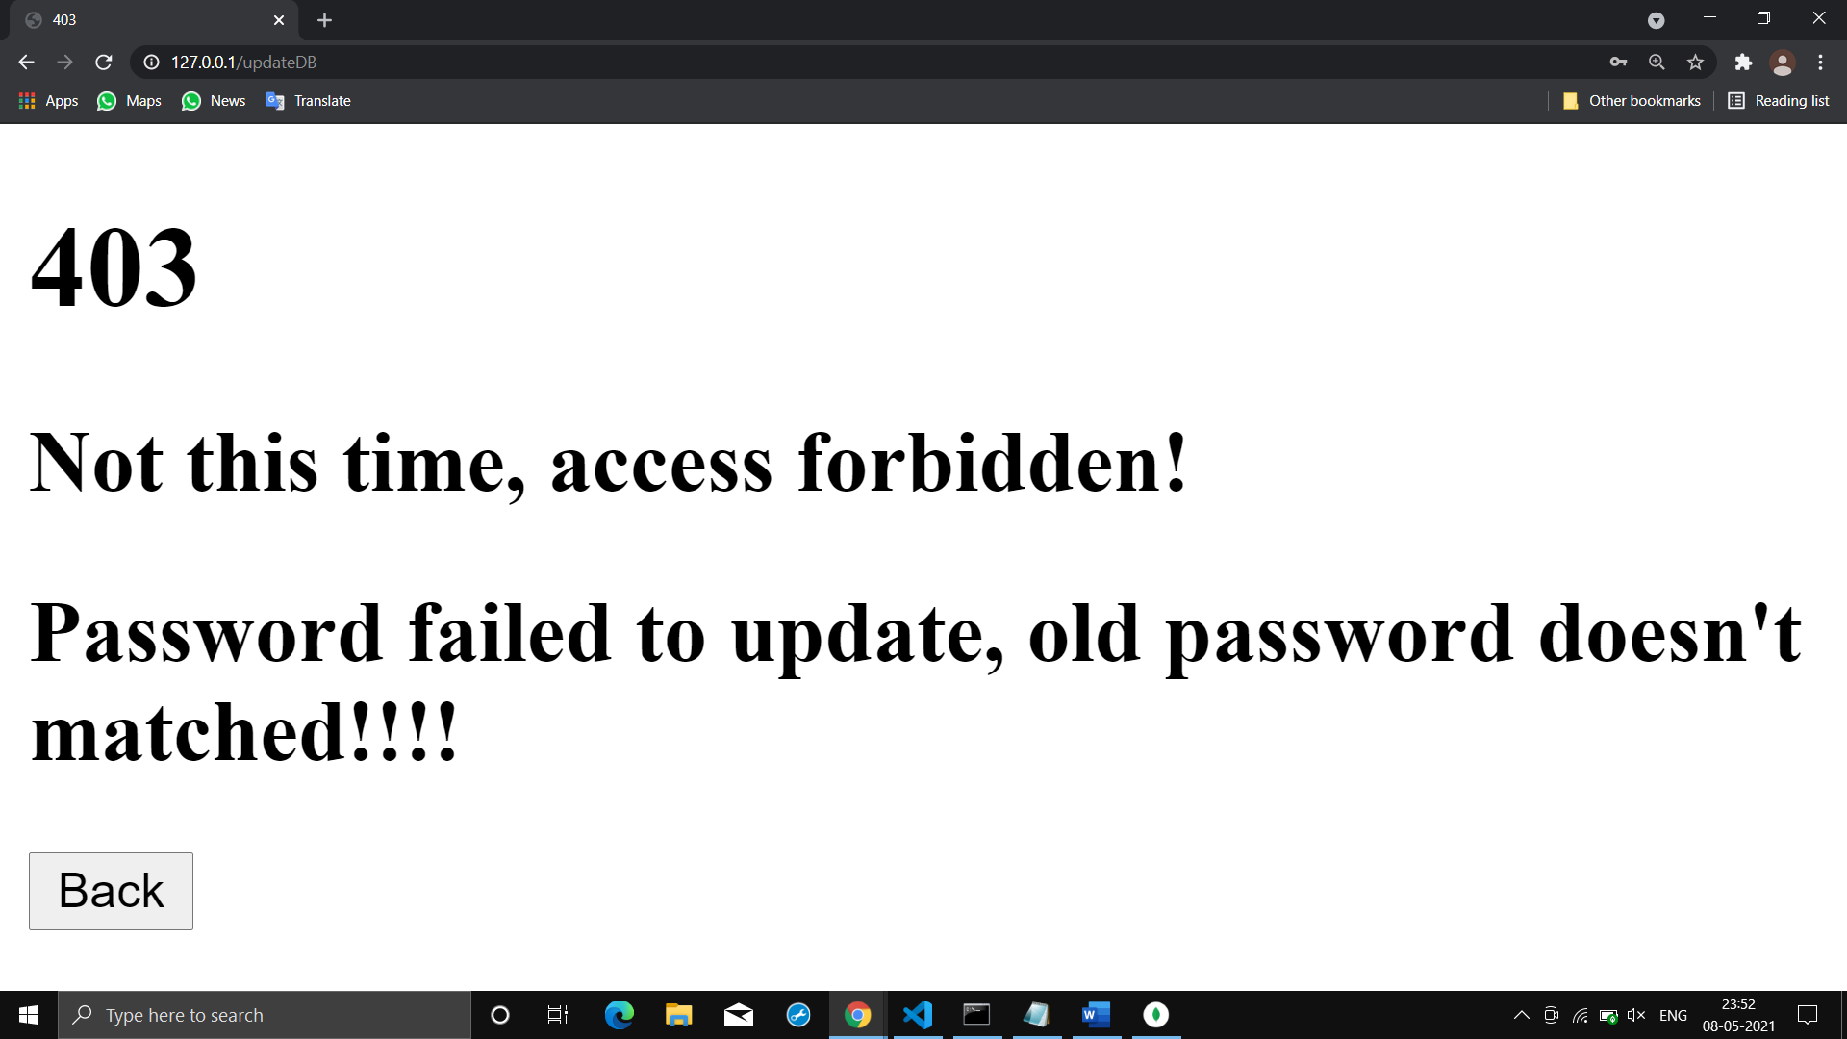

**D: (Delete Account)**

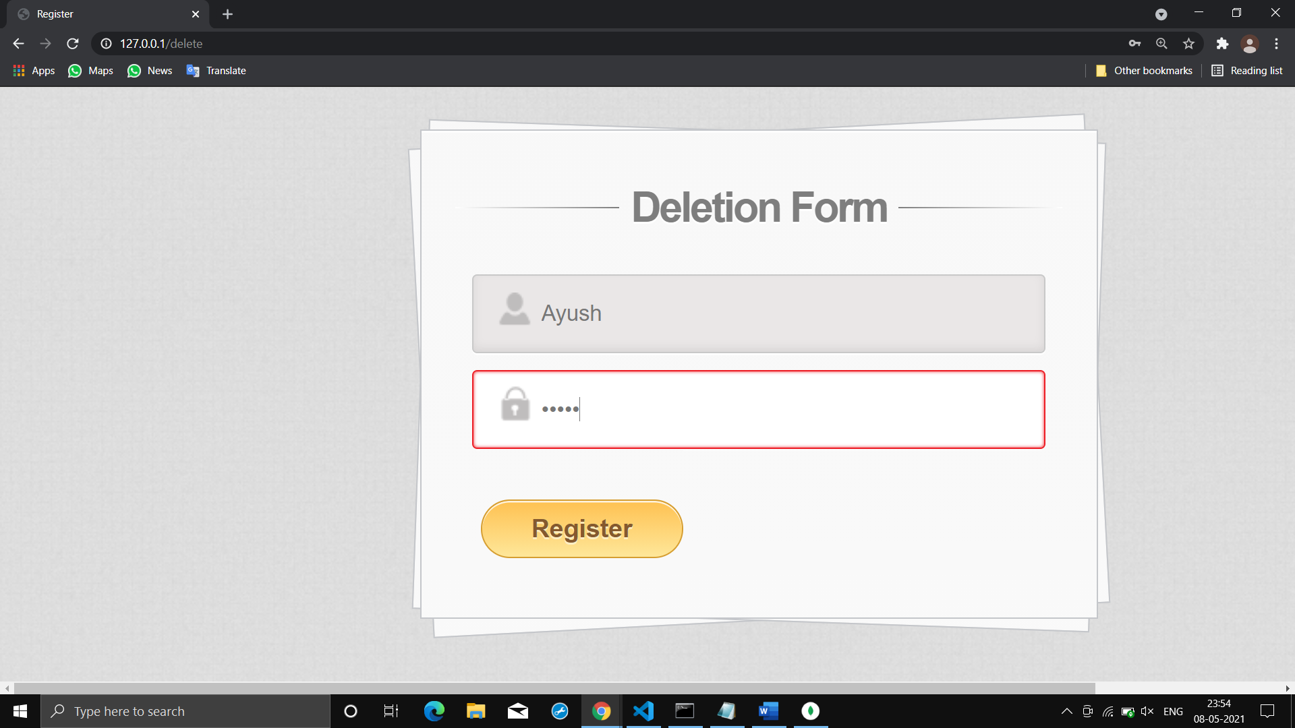

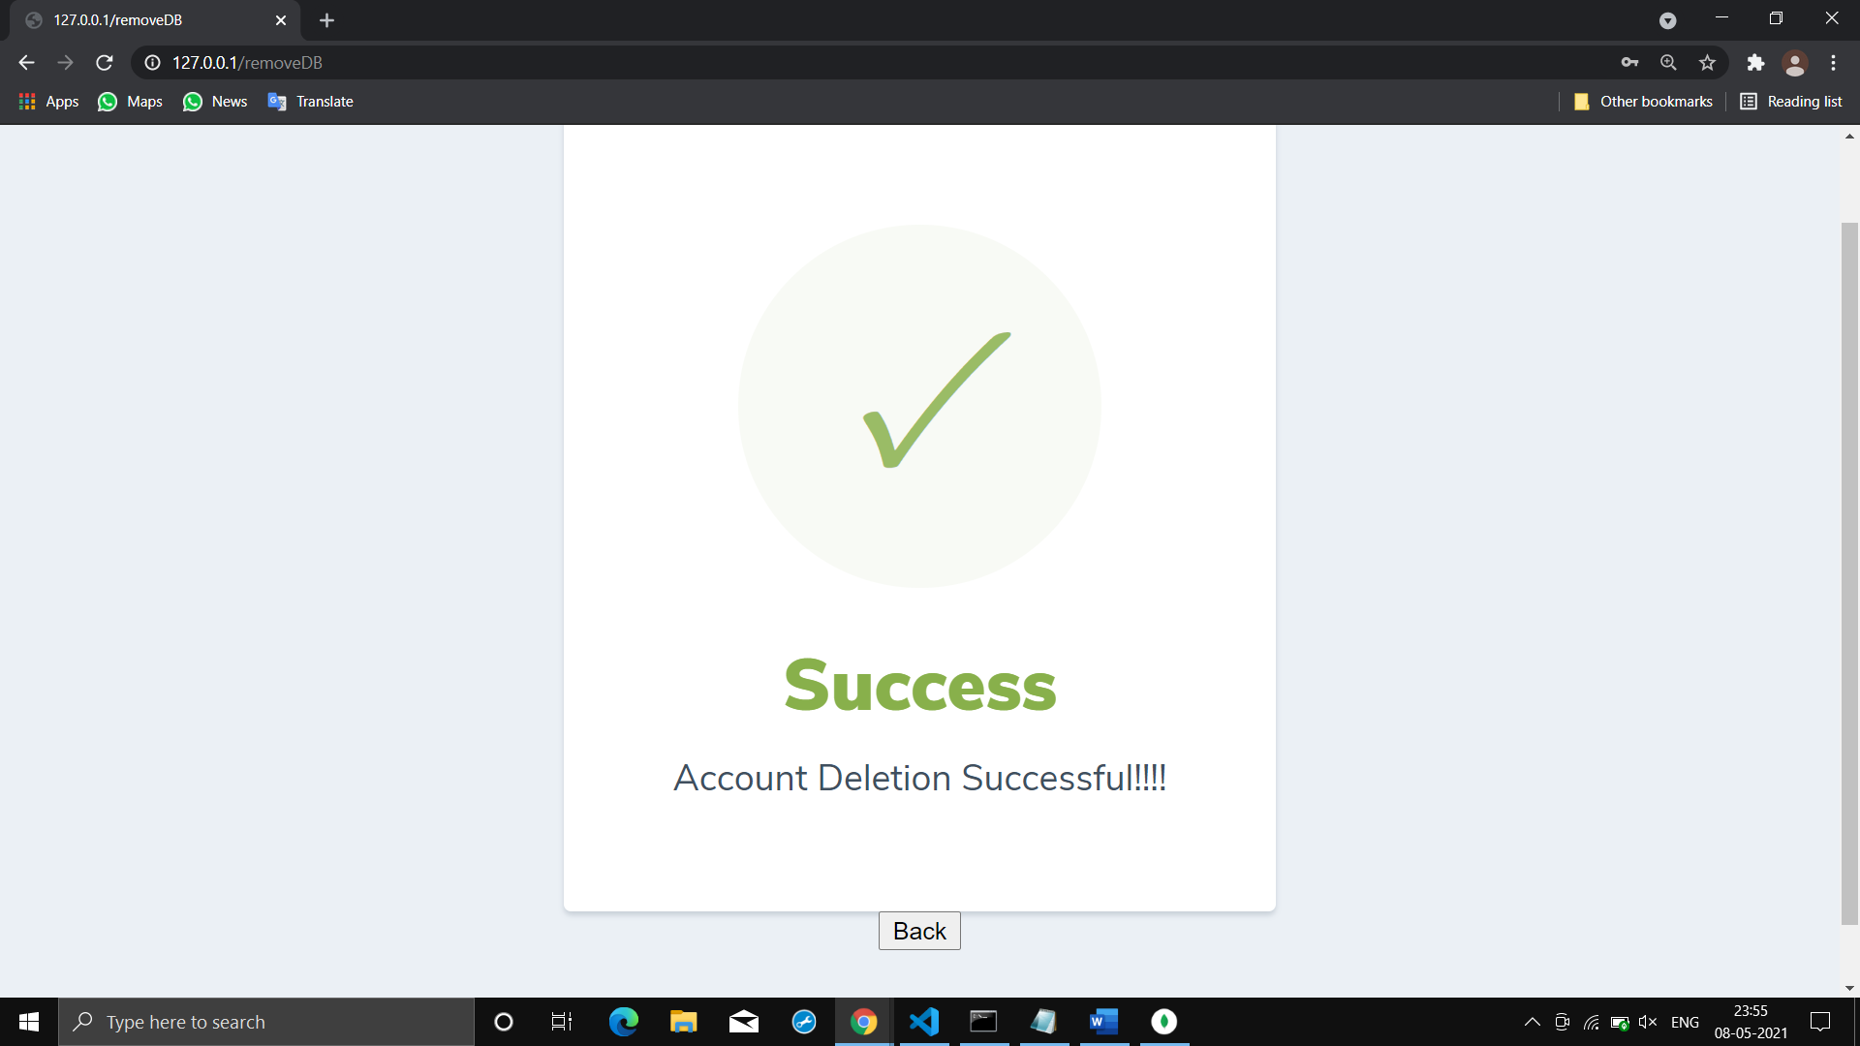

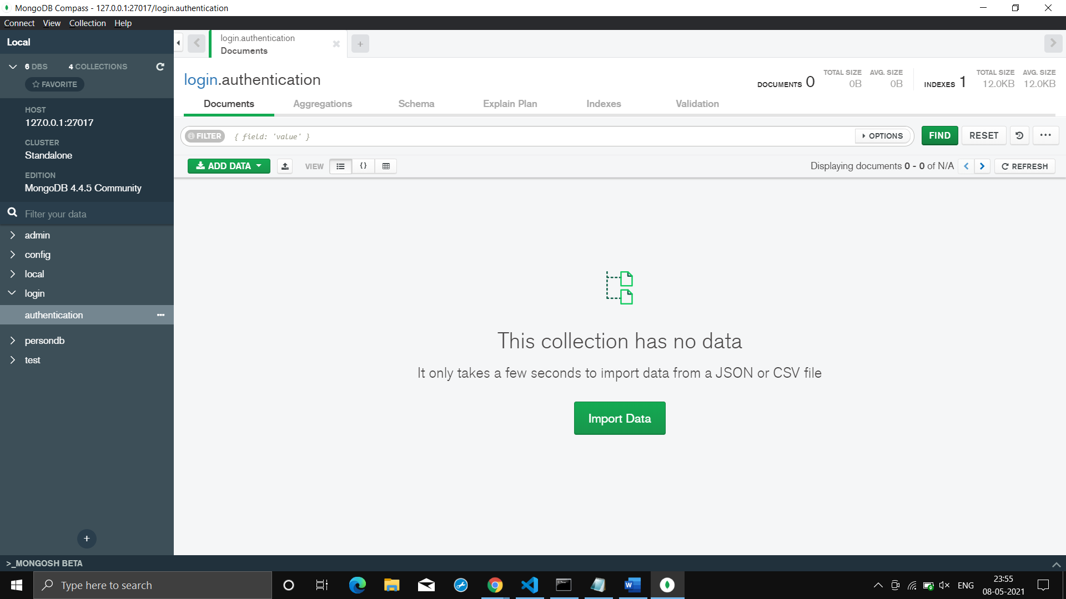

**👉Here, if you give wrong password or username it will give error!!!**



**🔷Things I Learnt:**

**⭕Data is always stored in file & files are always stored in folder, this kind if system is known as file system  
⭕Data Model refers to the way we manage the data, or the way we store the data  
⭕In SQL it is compulsory to have a schema & it not so flexible whereas NOSQL doesn't have the schema & is more flexible then SQL. In SQL we have tables which contains record whereas in NOSQL we have collection which contains document.  
⭕In NOSQL world we have collection(equivalent to table), which contains file/document(equivalent to record i.e. one file per record), hence there is no correlation between files. There is no fixed pattern in which data has to be entered & also there is no restriction that we have to take same data, as we had in SQL DB  
⭕Insert operation is used to create document in the database  
⭕Database which doesn't have schema is known as schema less DB like mongodb  
⭕Mongo db is document oriented DB where each recode is represent by an individual document  
⭕CRUD operation refers to Create(insert()), Read(find()), Update(update()) & delete(deleteOne()) operations that can be performed on mongodb  
⭕For configuration of Mongodb server we need to download the s/w & then simply need to install it**

**⭕Mongod is server side s/w & mongo is client side s/w**

**⭕Mongo db takes input only in JSON format, each document is enclosed in curly braces & each key value pair is separated by comma. Also we can have document inside the document known as embedded documents**

**⭕Compass is the GUI way to interact with mongodb server**

**⭕Mongodb api is one of the way in which we can integrate mongodb with programming languages, we simply need to provide connection string of mongodb server so that our app can connect to server**

**⭕Indexing is the way to store data which basically increases the performance. We create index table in which we store key ,which is frequently used for filtering the data, & it corresponding id. We store key in sorted format  
⭕In cluster to avoid SPOF we create multiple copies of data known as replica set  
⭕Sharding is the concept in which we creates data groups with in entire data & we store individual groups in on of the node of the cluster, also we maintain the replica of that group of data  
⭕COLLSCAN is on of the by default plan used by mongo db for searching data in data base, it's basically like linear searching. When we creates indexes and uses indexing for searching then search plan of mongo db changes to IXSCAN  
⭕When in indexing we use more then one field as a key then this type of indexing is known as compound index  
⭕Aggregration pipeline basically allows us to pass the output of one query to other query for finally achieving desired output  
⭕In Mongo db cluster the master is known as mongo router as master is the one who routes the request of client to respective node  
⭕Mongo atlas is the mongo db cluster or distributed mongo db from company itself**

**⭕In referential model we store data only one & where ever we need it we basically pass the reference of that stored data**